Azamat Salamatov

Doctor Tai Cleveland

COMP-3324 – Computer Networks

Lab 6 - Intro to Splunk – Searching

3/12/2023

Splunk – Searching

Contents

Result Image: 1

What I learned: 1

# Result Image:

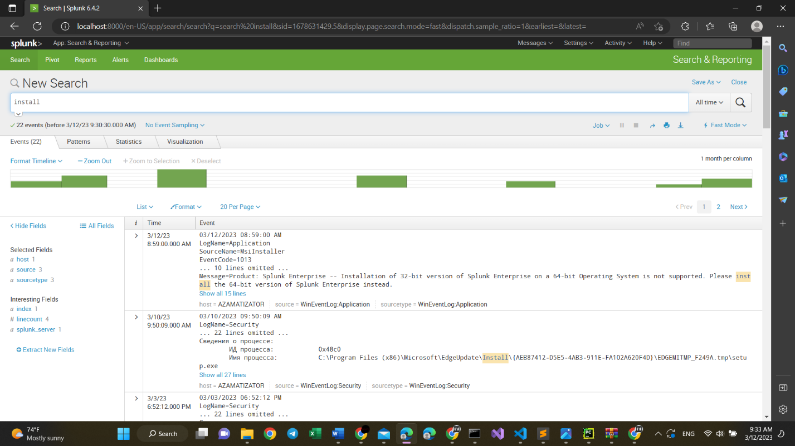

# What I learned:

* Splunk is a software for searching, monitoring, and analyzing machine-generated data via a web-style interface.
* Splunk has been changed and updated a lot, and I had a hard time to set and configure all the settings showed in the Lab Guide. However, Searching the Internet, watching YouTube videos finally helped me.
* I used Splunk Enterprise Version Downloaded from a pirate website.
* When trying to download from the official website, I could not download it. Because it was disallowed by the US laws.
* So, finally, Now I am familiar with some searching and analyzing of my Windows 11’s data via Splunk web-style Interface.

*P.S.*

*Some of the words in the image are in Russian, because my laptop was configured in my home country.*